IT-SIMPLERA INSTITUTE
Cyber Security Analyst Internship program



INTERNSHIP WEEKLY REPORT

SUBMITTED BY | MALIHA GUL
ROLE | RED TEAM INTERN
INSTITUTE | IT-SIMPLERA INSTITUTE
INSTRUCTOR | TALAL REHAN
WEEK | WEEK 01
DATE OF SUBMISSION | 2 JULY 2026

Table of Content
- Five Real-World Cyberattacks ……………………………..2
- Understanding the CIA Triad ……………………………….3
- Three Cybersecurity Tools …………………………………………4
- Secure Home Network Diagram …………………………….7
- Cybersecurity Analyst Role …………………………………..8
- References ……………………………………………………11

Task 1: Research Five Real-World Cyberattacks
# | Cyberattack | Year | Organization | Attack Type | Description | Impact
1 | WannaCry | 2017 | NHS, FedEx, Renault and others | Ransomware | WannaCry exploited the EternalBlue vulnerability in Microsoft Windows, encrypted victims' files, and demanded ransom payments in Bitcoin. It spread automatically across networks. | Over 230,000 computers in more than 150 countries were infected, causing billions of dollars in losses and disrupting healthcare services.
2 | Equifax Data Breach | 2017 | Equifax | Data Breach | Attackers exploited an unpatched Apache Struts vulnerability and gained unauthorized access to customer databases containing sensitive personal information. | Personal information of approximately 147 million people was exposed, resulting in financial losses and legal penalties.
3 | SolarWinds Attack | 2020 | SolarWinds | Supply Chain Attack | Attackers inserted malicious code into SolarWinds Orion software updates, allowing unauthorized access to government agencies and private organizations. | Numerous government agencies and major companies were compromised, leading to large-scale cyber espionage.
4 | Colonial Pipeline | 2021 | Colonial Pipeline | Ransomware | The DarkSide ransomware group encrypted company systems, forcing the shutdown of a major fuel pipeline in the United States. | Fuel shortages occurred across the U.S. East Coast, and the company paid millions of dollars in ransom.
5 | Yahoo Data Breach | 2013–2014 | Yahoo | Data Breach | Cybercriminals gained unauthorized access to Yahoo's user database and stole billions of user account records. | Approximately 3 billion user accounts were compromised, damaging Yahoo's reputation and company value.

Task 2
Understanding the CIA Triad
The CIA Triad is the foundation of information security. It consists of three core principles that help protect information and computer systems from cyber threats. These principles are Confidentiality, Integrity, and Availability.
CIA Principle | Description
Confidentiality | Ensures that sensitive information is accessible only to authorized users. Violations include unauthorized access, data theft, and information leakage. Typical security controls include encryption, passwords, multi-factor authentication (MFA), and access control.
Integrity | Ensures that data remains accurate, complete, and unaltered by unauthorized users. Violations include data modification, tampering, and unauthorized changes. Common controls include hashing, digital signatures, checksums, and version control.
Availability | Ensures that systems, networks, and data remain available to authorized users whenever needed. Violations include ransomware attacks, hardware failures, and Denial-of-Service (DoS/DDoS) attacks. Typical controls include backups, disaster recovery plans, redundant systems, and firewalls.

CIA Triad Mapping to Researched Cyberattacks
The table below shows which component(s) of the CIA Triad were affected by each researched cyberattack.
Cyberattack | Confidentiality | Integrity | Availability
WannaCry (2017) | Not directly | Not directly | Violated
Equifax Data Breach (2017) | Violated | Not directly | Not directly
SolarWinds Attack (2020) | Violated | Violated | Not directly
Colonial Pipeline (2021) | Not directly | Not directly | Violated
Yahoo Data Breach (2013–2014) | Violated | Not directly | Not directly

Task 3: Research Three Cybersecurity Tools

1. Wireshark

Purpose
Wireshark is a network protocol analyzer used to capture and inspect data packets traveling across a network.

Function
- Captures live network traffic.
- Displays packet details such as source and destination IP addresses.
- Helps identify suspicious or malicious network activity.
- Assists in troubleshooting network issues.

Use Case
A cybersecurity analyst uses Wireshark to detect unauthorized network connections, investigate malware communication, and diagnose network problems.

Advantages
- Free and open-source.
- Supports hundreds of network protocols.
- Easy packet filtering and analysis.

Limitations
- Requires networking knowledge.
- Large captures can be difficult to analyze.

2. Nmap (Network Mapper)

Purpose
Nmap is an open-source tool used to discover devices and services running on a network.

Function
- Detects active hosts.
- Scans open ports.
- Identifies operating systems.
- Finds running services and software versions.
- Detects security vulnerabilities.

Use Case
A security analyst performs regular network scans to identify open ports that attackers could exploit.

Advantages
- Fast and accurate.
- Supports multiple scan types.
- Widely used in penetration testing.

Limitations
- Can be detected by intrusion detection systems.
- Incorrect usage may trigger security alerts.

3. Metasploit Framework

Purpose
Metasploit is a penetration testing framework used to identify and verify system vulnerabilities.

Function
- Tests system security.
- Simulates cyberattacks.
- Validates vulnerabilities.
- Generates security reports.

Use Case
An ethical hacker uses Metasploit to determine whether a vulnerability can actually be exploited before recommending security improvements.

Advantages
- Large database of exploits.
- Automates penetration testing.
- Supports custom modules.

Limitations
- Should only be used with authorization.
- Requires cybersecurity knowledge.
Comparison of Cybersecurity Tools
Tool | Purpose | Main Function | Used By
Wireshark | Network Monitoring | Packet Capture & Analysis | Network Security Analysts
Nmap | Network Scanning | Discover Hosts & Open Ports | Penetration Testers
Metasploit | Penetration Testing | Exploit Vulnerabilities | Ethical Hackers

Task 4: Secure Home Network Diagram

Diagram

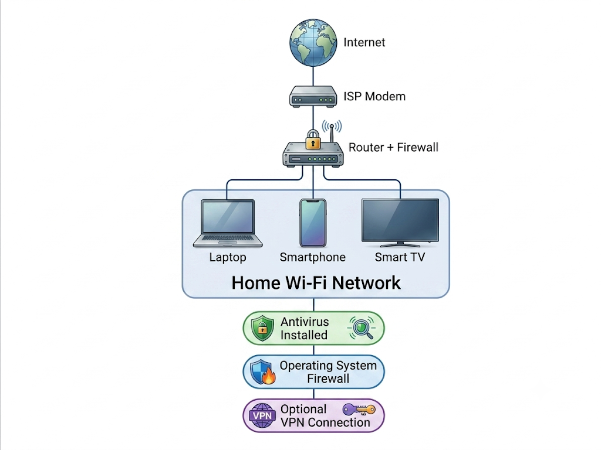

Explanation

Internet
Provides access to websites and online services.

ISP Modem
Connects the home to the Internet Service Provider.

Router
Distributes the internet connection to all home devices.

Firewall
Blocks unauthorized access and filters incoming and outgoing traffic.

Antivirus
Protects devices from viruses, malware, ransomware, and spyware.

Devices
Examples include:
- Laptop
- Desktop Computer
- Smartphone
- Tablet
- Smart TV

VPN (Virtual Private Network)
Encrypts internet traffic and protects user privacy, especially on public Wi-Fi.

Task 5: What Does a Cybersecurity Analyst Do Every Day?

Introduction
A cybersecurity analyst protects an organization's computer systems, networks, and sensitive information from cyber threats. Their primary responsibility is to monitor systems, detect attacks, and respond quickly to security incidents.

Daily Responsibilities

1. Monitor Network Activity
Cybersecurity analysts continuously monitor network traffic using security monitoring tools to identify suspicious activities and prevent cyberattacks.

2. Detect Security Threats
They investigate:
- Malware
- Ransomware
- Phishing attacks
- Unauthorized access
- Data breaches

3. Analyze Security Logs
They review logs generated by:
- Firewalls
- Servers
- Antivirus software
- Intrusion Detection Systems (IDS)
These logs help identify abnormal activities.

4. Respond to Security Incidents
When an attack occurs, analysts:
- Isolate infected systems.
- Remove malware.
- Recover lost data.
- Restore services.
- Investigate the root cause.

5. Perform Vulnerability Assessments
Analysts scan systems for weaknesses using tools like:
- Nmap
- Nessus
- OpenVAS
They recommend fixes before attackers can exploit vulnerabilities.

6. Install Security Updates
They ensure:
- Operating systems are updated.
- Applications are patched.
- Firmware is upgraded.
Regular updates reduce security risks.

7. Educate Employees
Cybersecurity analysts conduct awareness training on:
- Strong passwords
- Safe browsing
- Email security
- Phishing prevention
- Social engineering

8. Create Security Reports
Analysts prepare reports describing:
- Security incidents
- Vulnerabilities found
- Risks
- Recommendations
- Compliance status
Skills Required
- Networking
- Operating Systems
- Linux
- Windows Security
- Risk Assessment
- Incident Response
- Communication Skills
- Problem Solving

Common Tools Used
- Wireshark
- Nmap
- Metasploit
- Microsoft Defender
- Splunk
- Nessus

Importance of a Cybersecurity Analyst
Cybersecurity analysts help organizations:
- Protect confidential information.
- Prevent cyberattacks.
- Reduce financial losses.
- Maintain customer trust.
- Ensure business continuity.
- Meet legal and regulatory requirements.

Conclusion
Cybersecurity analysts play a vital role in protecting digital systems from evolving cyber threats. By monitoring networks, detecting vulnerabilities, responding to incidents, and educating users, they help ensure the confidentiality, integrity, and availability of organizational information. As cyberattacks become more sophisticated, the demand for skilled cybersecurity analysts continues to grow.

References :
- National Institute of Standards and Technology (NIST). (2024). Cybersecurity Framework (CSF) 2.0. https://www.nist.gov/cyberframework
- Cybersecurity and Infrastructure Security Agency (CISA). (2024). Cybersecurity Resources. https://www.cisa.gov
- Microsoft Security. (2024). Security Documentation. https://learn.microsoft.com/security
- Wireshark Foundation. (2024). Wireshark User Guide. https://www.wireshark.org
- Nmap Project. (2024). Nmap Reference Guide. https://nmap.org
- Rapid7. (2024). Metasploit Documentation. https://docs.metasploit.com

